# Summer Workouts

Dynamic Stretching

Should be done before ALL workouts.

Monday, Wednesday, Friday- Weights

3 days a week of weight lifting... you should have at least 1 day between lift days. This should take about 45-60 mins.

Tuesday, Thursdays- Jump Training

1. days a week of jump training to increase vertical and explosiveness
2. days a week- Cardio

There are many options for cardio to choose from. It is important that you sprint at least once a week.

Doing endurance cardio (longer distance) at least once a week will be very beneficial for pre-season. You can swap up what you do for the third day of cardio. Included: Sprints, Jump Rope Cardio, Agilities, Interval Training. You can also come-up with your own.

Ab Circuits

Do an Ab Circuit at least 3 times a week on weight days.

Volleyball Workouts

Play as much volleyball as possible to get ready for our pre-season

YouTube is a great resource to find videos any exercises that you are unfamiliar with!

Make sure you use good form at all times!

## Functional Dynamic Warm-up Routine

You should complete this warm-up prior to every workout. We will begin each practice with this routine, so it's important that you've done this so that it doesn't make you sore during pre-season.

Standing: All done for 45 Seconds each

l. Jumping jacks

1. Arm Circles (both directions gradually getting bigger)
2. Arm Scissors (alternating left and right on top)
3. Shoulder Dislocates
4. Leg Gate Swings
5. Good Mornings

Walking Warm-up: All done to half-court 2 Times

1. High Knee with knee pull
2. High Knee March with back Rotation
3. Sumo
4. Walking Lunges with lateral reach
5. Long stride with calf and hamstring rockers
6. Butt kickers
7. Straight Leg Marches with Arms straight
8. Lateral Lunges
9. Inch Worm (to foul line)
10. Spiderman (to foul line)

Jog Warm-up: All done to half court 2 times

1. Power Skips
2. Carioca
3. Power Bounds
4. Skip kicks
5. 5 yards is 3 steps(Long Strides)
6. Butt Kickers
7. Power Shuffles
8. High Knee Cross Overs

## Sprints

You should alternate sprint workouts each week. You should rest equal to the time that it takes you to run the sprint. For example, if it takes you seconds to run the sprint you should rest for :10 seconds before starting the next sprint.

Sprint Workout #1

10 meters — 10 times

20 meters-6 times

40 meters- 4 times

20 meters- 6 times

10 meters- 10 times

Sprint Workout #2

20 meters- 15 times

30 meters- 10 times

40 meters-5 times

50 meters- 2 times

100 meters- 1 time

## Suicides

Use the length of the volleyball court and having the end line as your BASE, you will sprint the following consecutively aiming for a time less than :60 seconds.

l. Base to near 10 foot line and return to base

1. Base to far end line and return to base
2. Base to center line and return to base
3. Base to far end line and return to base
4. Base to far 10 foot line and return to base
5. Base to far end line and return to base
6. Base to far end line and return to base

# Jump Ropes and Jump. Circuit

Jumping rope will condition your hips, knees, and ankles for jumping as well as providing cardio.

With Jump Rope:

l. Double Leg (DL)- both feet contact the ground at the same time

1. Single Leg (SL)- one leg at a time
2. High Knees (HK)- double foot contact and then pull knees to chest like a tuck jump.
3. Running (R)- alternate legs each revolution in a running motion
4. Regular Shuffle (S)- like a boxer, shift weight from one foot to the other

|  |  |  |  |  |  |  |  |  |  |  |  |
| --- | --- | --- | --- | --- | --- | --- | --- | --- | --- | --- | --- |
| Weeks | Time |  | s | SLR | s | SLL | s | HIC | s | R | s |

1 & 2 11•30 2:002:30 3:00

* 1. 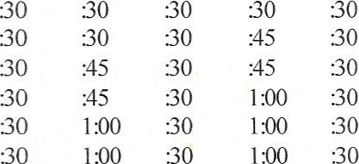12:45 2•30so2:30 3•30
  2. 13:45 3:002•30 3•30
  3. 15:00 3:003:00 4:00
  4. 16:00 3:001:003:00 4•.30  16•30 4:00 1:00 3:00 3:30

Jump Circuit (without jump rope):

l. Regular Shuffle (S)- like a boxer, shift weight from one foot to the other

1. Burpees (B)- put hands on floor, kick legs back to push-up position, pull legs back into chest, explode up with arms in the air for height
2. Tuck Jumps (TJ)- Knees to chest
3. Mountain Climbers (MC)- legs run back and forth with hands on the floor in a push-up position
4. One-Step Block Jumps (Is)- one step to the right, block jump for height, one step to the left, block jump for height, and repeat.

Week Time s s s MC s Is

 6:40 Repeat 1st 6 exercise 20s each

3 6:30 Repeat 1st 5 exercise 20s each

 7:00 Repeat lst 6 exercise 30s each

6  8:00 Repeat all exercise :30s each

8 6:00 Repeat all exercise 20s each

## Agilities

These can be done with lines or with imaginary lines.

Start by doing 2 sets or each (A-F) for :30 seconds. Add a set every 2 weeks.

|  |  |  |  |
| --- | --- | --- | --- |
| Agilities | Upper | | Upper |
| should be done for quickness and speed,  NOT  HEIGHT! Upper  Left (UL) | Center | | Right (UR) |
| Left | Center (C) | | Right |
| Center |  | | Center |
| Bottom | Bottom | | Bottom |
| Left (BL) | Center | | Right (BR) |
| (BC) | D |
| 1. Start with both feet C. |  | 1. Start with both feet together in BC. | |
| 2. Jump Right foot into UR and left foot into UL. | | 2. Jump right foot to RC and left foot to LC. | |
| 3. Return both feet to C. | | 3. Jump both feet together to UC. | |
| 4. Jump right foot into BR and left foot into BL. | | 4. Jump right foot to RC and left foot to LC. | |
| 5. Return both feet to C. | | 5. Jump both feet together in bottom C. | |
| 6. REPEAT until time is up. | | 6. Repeat until time is up. | |
| 1. Stan with right foot in UR and left foot in BL. | | l. Start both feet together in C. | |
| 2. Jump right foot to RC and left foot to LC. | | 2. Jump both feet together to every box, | |
| 3. Jump right foot to BR and left foot to UL. | | returning to the center between every jump. 3. | |
| 1. Jump right foot to RC and left foot to LC. 2. Return to starting position. 3. Repeat until time is up.   c | | Repeat until time is up. | |
| l. Start with both feet in C. | | l. Start with right foot in UR and left foot in BL. | |
| 2. Jump both feet together to UC. | | 2. Jump both feet together to C. | |
| 3. Return to C. | | 3. Jump right foot to BR and left foot to UL. | |
| 4. Jump both feet together to RC. | | 4. Return both feet to C. | |
| 5. Return to C. | | 5. Repeat until time is up. | |

1. Jump both feet together to BC.
2. Return to C.
3. Jump both feet together to LC.
4. Return to C.
5. Repeat until time is up.

# Minute Interval Training

Interval training is based on your choice (run, bike, climb, elliptical machine, etc.) (running is preferred). . . % is based on your 100% full out max, so you should be tired when you hit 80% and 90%. You can increase intensity by

increasing speed, incline, or resistance.

Minute Intensity Treadmill Example Speed 1 50% 5.0

1. 50% 5.0
2. 60% 6.0
3. 70% 7.0
4. 8.0
5. 90% 9.0
6. 6.0
7. 70% 7.0
8. 80% 8.0
9. 90% 9.0
10. 60% 6.0
11. 70% 7.0
12. 80% 8.0
13. 90% 9.0
14. 60% 6.0
15. 70% 7.0
16. 80% 8.0
17. 90% 9.0
18. 100% 10.0
19. 50% 5.0

## Volleyball Workout

Part I- Shoulder Specific

Whether you are an offensive or defensive player, or both...this will prepare you for multiple repetitions of attacking and serving. This will prepare you and decrease the chance of injury. This can all be done against the wall, but any opportunity that you have to actual attack and serve on the court would be beneficial.

Week 1: Attacking motion against wall 4 x 10 /Serving motion against wall 4 X 8

Week 2 & 3: Attacking 5 X25/Serving 4 x 10

Week 4: Attacking 6 x 25/Serving 5 x 10

Week 5: Attacking 10 x 20 /Serving 6 x 10

Week 6: Attacking 8 x 30 /Serving 8 x 8

Week 7 & 8: Attacking 10 x 25 /Serving 10 x 8

Part II- Passing/Defense Leg Conditioning

Baby footwork: forward, back, right, left, and repeat. Remain low and in a good passing position, arms out ready to pass. One step with both legs in each direction, get balanced, pass, and return to base. Week I & 2: 4 x :30 seconds

Week 3: 4 x :45 seconds

Week 4: 4 x 1:00 minute

Week 5: 5 x :45 seconds

Week 6: 5 x 1:00 minute

Week 7 & 8: 6 x :45 seconds

Part Ill- Blocking Footwork

I Step: Push off L foot and raise R foot, land on both balanced (to right). Push off R foot and raise L foot, land on both balanced (to left).

1. Step: Crossover and close. Both directions
2. Step: Step with foot in same direction as moving, crossover and close. If you are a middle, do 3 steps. If not, do more I and 2 steps. Week 1: 6 x each

Week 2: 8 x each

Week 3 & 4: 10 1-step, 8 2-step, 6 3-step

Week 5 & 6: 10 1-step, 10 2-step, 6 3-step

Week 7 & 8: 10 1-step, 10 2-step, 10 3-step

## Abdominal Exercises

Set # I

3 x :30 each

l. Double Leg Raises

1. Twist- raise shoulders off the ground, keeping your feet flat on the floor and knees bent, slowly twist torso from side to side. You want to take your left elbow to your right knee and your right elbow to your left knee.
2. Oblique Twists: 3 x 15 R, 3 x 15 L
3. Bicycle- extend legs all the way out
4. Scissors Side to Side- legs straight out, raise 45 degrees, keeping legs tight cross right over left, then left over right, and repeat.
5. Scissors Up & Down- same as above, but move right leg up while moving left leg down (small motion), then left up and right down.

Set # 2

With Weights:

l. 4 x 10 Crunches

1. 4 x 10 abdominal twists seated (lean back slightly, knees together and bent, twist weight from side to side)
2. 4 x 10 elevated toe touches (starting position- laying on back, hold weight behind your head with arms fairly straight.. .hold legs up in the air also fairly straight. Movement- raise weight above head and touch toes with it, not moving legs, when touching weight to toes push upward for a crunch).
3. 4 x 10 back crunches/sit-ups- small amount of weight... lay on stomach with weight either on back or held on chest, raise upper body.

Set # 3

l. Full Sit-Ups- 3 x 15... hands behind head, keep elbows back and sit up all the way, do not use arms to sit up or allow your elbows to come forward.

1. Superman- 3 x15... laying on your stomach, lift alternate arm alternate leg and hold for 5 seconds, repeat.
2. 6 inches- 3 x :45 seconds... hold legs straight and 6 inches off the ground.
3. Double leg row- 3 x 15...sitting and leaning slightly back pull both knees to chest and extend out.
4. Crunches- 3 x 30
5. Regular Plank- 4 x •30 seconds (increase time as it becomes easier)
6. Side Planks- 2 x •30 each side (increase time as it becomes easier)

Set #4

3 x :30 secs {Increase by 10 seconds every time you do this}

l. Regular Plank (on elbows)

1. Side Planks (on both sides)
2. Side Plank Twists (on both sides)
3. Plank alternate bringing knees to elbows
4. Plank alternate bringing foot off the ground
5. Planks with superman (raise arm and opposite foot at same time and switch)

Del Val Workout Summer Strength Training

|  |  |  |  |  |  |  |  |
| --- | --- | --- | --- | --- | --- | --- | --- |
| Week Starting . | | 17-Jun | 24-Jun | 01 -Jul | 08-Jul | Wei hts Used | Weights Used |
| Intensity  % | | 70-75% | 75-80% | 75% | 80-85% |  |  |
| Session 1 | | volume | volume | volume | volume |  |  |
| Squat | | 3x10 |  | 3x10 | 5x5 |  |  |
| Single Step-up | | 3xI O each | 4x10 each | 3x10 each | 4x5 each |  |  |
| Glute Ham or Leg Curl  Machine | |  |  |  |  |  |  |
| Upright Row DB) | |  |  |  |  |  |  |
| Physio Ball DB Pullover | | 3x10 |  |  | 5x5 |  |  |
|  | |  |  |  |  |  |  |
|  | | 70-75% | 75-80% | 75% | 80-85% |  |  |
| Session 2 | | volume | volume | volume | volume |  |  |
| Bench Press | | 3x10 |  |  |  |  |  |
| Pulldown | |  |  | 3<10 |  |  |  |
| SA DB Row | | 3x10 each | 4x10 each | 3xI O each | 3x5 each |  |  |
| Back Extension/Fl | | 3x10 |  | 3x10 |  |  |  |
| 360 Lateral Raise | |  | 3x12 | 3x12 | 3<10 |  |  |
|  | |  |  |  |  |  |  |
| Intens | | 55-60% | 60% | 65% | 65% |  |  |
| Session 3 | | volume | volume | volume | volume |  |  |
| Le Press or Front Squat |  | 3x10 |  |  | 5x5 |  |  |
| Split Squat | | each | 4x10 each | 3xIO each | 5x5 each |  |  |
| RDL | |  |  |  |  |  |  |
| Shoulder Circuit | | 3x(3x10) | 3x(3x10) | 3x(3x10 | 3x(3x10) |  |  |
| Bench Dips | |  |  |  |  |  |  |
|  | |  |  |  |  |  |  |
|  | |  |  |  |  |  |  |

75%

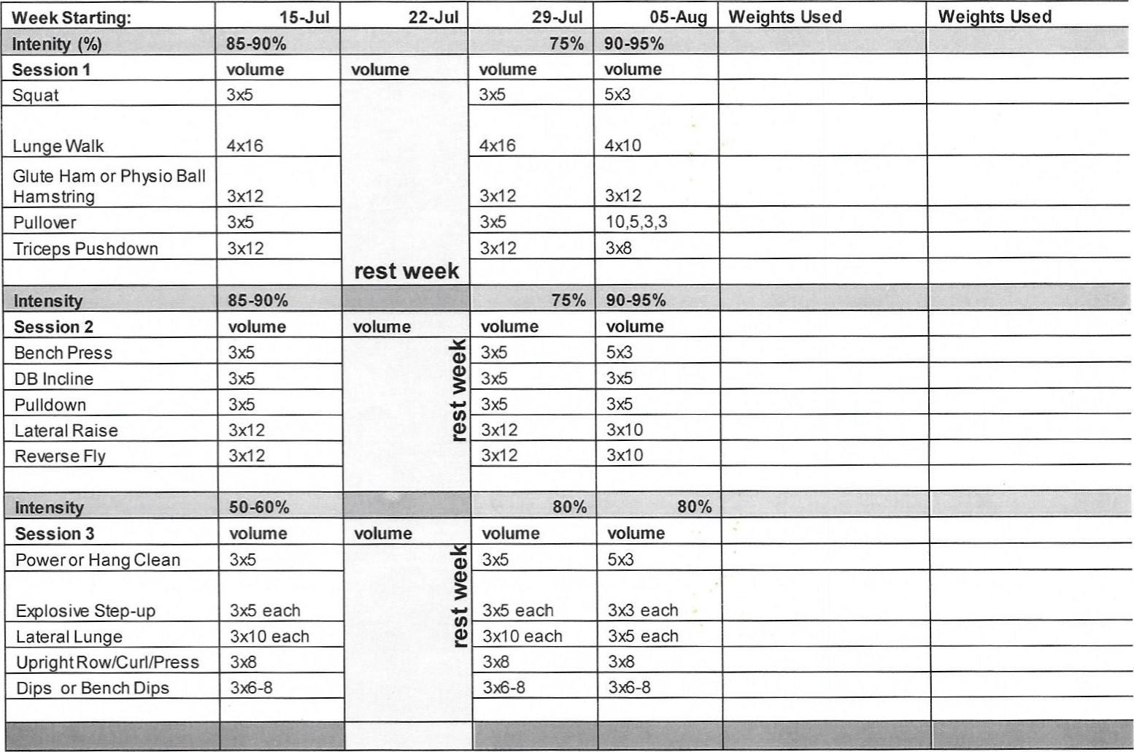

Del Val

Workout

Summer

Strength

Training

Del VaI Workout Summer Strength Training

|  |  |  |  |  |  |  |  |
| --- | --- | --- | --- | --- | --- | --- | --- |
| Week Starting: | | 12-Au | 19-Aug | 26-Aug |  | Wei hts Used | Wei hts Used |
| Inten• %) | | 70-75% | 75% | 80% |  |  |  |
| Session I | | volume | volume | volume |  |  |  |
| Squat | | 5x5 |  | 5x3 |  |  |  |
| Box Jumps or Tuck Jumps | |  |  |  |  |  |  |
| Ste -u wt. | | 3x5 each le | 3x5 each le | 3x5 each le |  |  |  |
| Split Squat Jump | | 3x5 each leg | 3x5 each leg | 3x5 each le |  |  |  |
| (Véd Ball Hamstring | |  |  |  |  |  |  |
|  | |  |  |  |  |  |  |
| Intens |  | 70-75% | 75% |  |  |  |  |
| Session 2 | | volume | volume | volume |  |  |  |
| Incline Press | | 5x5 | 36 | 50 |  |  |  |
| DB Bench Press | | 5x5 |  | 3x5 |  |  |  |
| Pulldown | |  |  |  |  |  |  |
| Bent Over Row | | 3x10 | 3x10 |  |  |  |  |
| DB Front/Lat Raise | |  | 3x10 | 3x8 |  |  |  |
|  | |  |  |  |  |  |  |
|  | | 70% | 75% |  |  |  |  |
| Session 3 | | volume | volume | volume |  |  |  |
| Power or Han Clean | | 36 | 3x5 | 3x3 |  |  |  |
| ho cover box or bench | |  | 3x5 |  |  |  |  |
| Lunge Walk | |  | 5x10 |  |  |  |  |
| RDL | | 5x5 |  |  |  |  |  |
| Physio Ball Push Up | |  |  |  |  |  |  |
|  | |  |  |  |  |  |  |
|  | |  |  |  |  |  |  |

Good Luck! Have Fun!